# Title of Short Report in Initial Capital Letters and No More Than Two Lines

Author 1, Author 2, Author 3, and Author 4

Department, Institution

Date

**Summary and Introduction**

This document presents a template for a short report in engineering and science. This format, which follows principles in *The Craft of Scientific Writing* [1], is for reports in which the main text is no more than five pages. Although this format does not include front matter such as a cover or table of contents, the format does accommodate back matter such as appendices.

Similar to the professional formats in books and journals, this format calls for indenting all paragraphs. In addition, for the text portion, you should use a serif typeface such as Times New Roman (12 points). However, for the title, the headings, and subheadings, a bold sans serif typeface such as **Calibri** is fine to use. The line spacing for this paragraph is to be single-spaced at 1.15 spacing. Also, as in common in books and formal reports, please do *not* skip lines between paragraphs.

In this first section of the report, you should introduce the report and perhaps provide a summary of the most important details. If you decide not to include a summary of the main results, then you would just name this section “Introduction.” As a transition to the middle portion of the main text, you should include sentences that map the remaining sections of the main text.

In writing any report, you should support your claims with evidence from reference sources. For reference listings in the text, this template follows the IEEE [#] format. Unlike publications in the humanities, publications in engineering and science typically use brackets for reference listings because scientific writing uses parentheses in so many other ways, such as identifying units and acronyms. Note that every reference listing in the text corresponds to a reference citation at the end. Likewise, every citation at the end has at least one reference listing in the document. In the references section at the end of the document, you will find sample citations for a book [1], a journal article [2], a presentation [3], a company report [4], a patent [5], an interview [6], a website [7], and a newspaper article [8].

## Main Heading

This section begins the middle of the main text in this short report. Note that all headings should be 12 points, flush left, and boldfaced. The heading can be either a sans serif typeface (as was chosen for the title and the two headings here) or a serif typeface (as occurs in the text portion). However, the text must be a serif type, as shown here. Use initial capitals for the title and headings. Note that the template inserts spacing before the heading (the spacing equivalent to one skipped line) and no line skips afterwards. Also, note that this short report format has no format for subheadings. If your report is so long that you need subheadings, you should consider a long report format. Otherwise, use paragraphs to show the organization of the section.

For both the title and section heading, use initial capitals as shown here. One convention, but not the only one, for using initial capitals is that you capitalize the first letter of the first and last words—no matter what the words. Then, you capitalize the first letter of every word except for articles, conjunctions, and prepositions that have fewer than four letters: *a, an, and, as, but, for, in, nor, of, on, or, out, the, to, up,* and *yet*.

This format for a short report readily accommodates illustrations, such as Table 1, which presents the customer needs for a design. As in almost all formats in engineering and science, this format calls for a table heading to appear above the table. The type size of that heading is 12 points. Also note that vertical space (one line skip) occurs before the table heading and similar vertical space occurs after the table. Unlike a figure, a table heading is a single phrase. If you have additional details to say about the table, those appear in the main text or in footnotes beneath the table.

**Table 1.** Customer needs and accompanying metrics and specifications for cardboard chair.

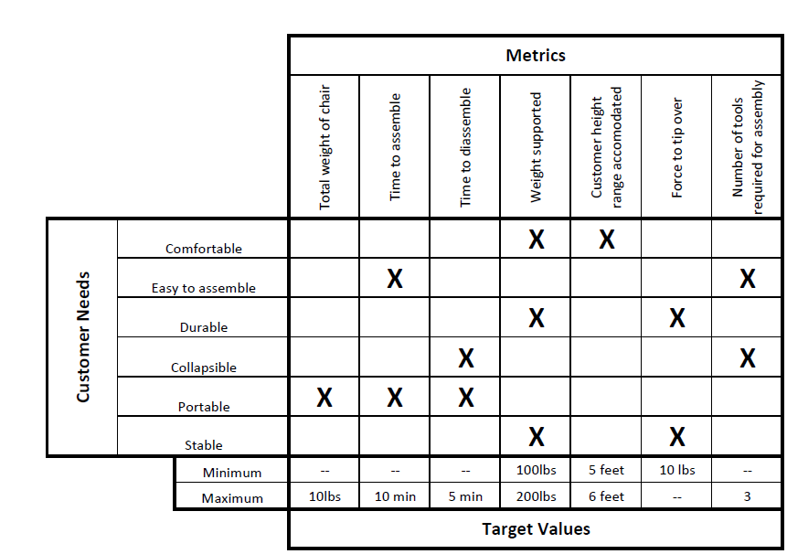

## Another Main Heading

Presented here is another section of this short report. Note that this heading should be parallel to the previous subheading. For instance, if this report were a progress report and if the previous section had the name “Work Completed on Project,” then this section likely would be “Work Remaining on Project.”

Just as this format for a short report allows for tables, so too does it allow for figures. For instance, if this document discussed the series of prototypes for a design, the report might include an illustration such as Figure 1. In formal documents, the illustration should occur *after* the paragraph that introduces it. In other words, you should not break paragraphs in a Microsoft Word document to insert an illustration. However, if your illustration is narrow enough (less than half the column width), you could inset the illustration within the paragraph. To do so, select the figure, and then select “In Line with Text” in the “Wrap Text” menu of the “Picture Tools Format” tab that appears in the menu bar.

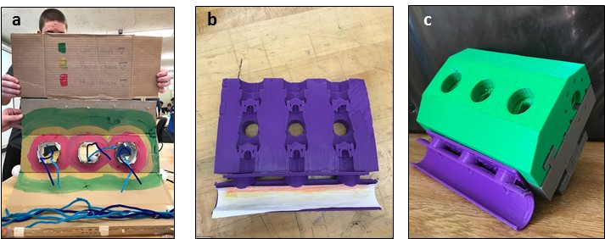

**Figure 1**. Sequence of prototypes for the model of the Clean Fleet Pumps: (a) zeroeth prototype,   
(b) alpha 1 prototype, and (c) alpha 2 prototype. In this format, after the caption’s initial phrase that defines the figure, you are welcome to add a sentence or two to explain unusual details.

As shown with the illustration above, a line skip occurs both before the figure and below the caption to separate the illustration from the text. In addition, Note the type size for the caption is smaller (11 points) than the main text and is set at a tighter spacing (1.0)—these changes in typography serve to set apart the caption from the main text. Finally, when introducing an illustration, do not use pointers such as *below* or *on the next page*. Your technical reader knows where the illustration is supposed to be placed—after the paragraph that introduces it or on the next page if not enough space exists below the paragraph. As such, saying “below” or “on the next page” is redundant and makes for needless work on later drafts.

## Another Main Heading

Presented here is another main heading of the main text. If this section were the last section, then you might use a heading name such as “Conclusions” or “Conclusions and Recommendations.”

In addition to writing the main text of the formal report, you might also want to include appendices. In general, an appendix presents secondary information that the audience might desire. In addition, an appendix might include information that a secondary Please remember that you should identify all appendices by name before they appear. For that reason, include a sentence or a parenthetical in the main text of the report that formally introduces each appendix. Included in this template is a generic appendix that discusses a typical appendix format (Appendix A). Also included is an appendix that provides instructions on incorporating references.

To incorporate an equation, such as for an efficiency calculation, center and set apart equations from the text with white space. Using Arabic numerals, number those equations that are referred to in the text. For example, in the wind turbine project, the torque supplied by the rotor, Trotor_S,is defined in equation 1:

$T{}_{rotor_S}= \frac{1}{2}C_{m}ρARU^{2}$ (1)

where *Cm* is the rotor-torque coefficient, ρ is the air density, *A* is the rotor’s cross-sectional area, *R* is the radius of the rotor, and *U* is the air velocity. When referring to equations, call them by their names: equation 1, equation 2, and so on. Also, when incorporating an equation, treat the equation as part of a sentence in the paragraph. Finally, do not let Microsoft Word indent or capitalize the word *where* following the equation. If necessary, you should override the program’s defaults.

Because you are writing as an engineer or scientist, the style of the writing is significantly different from the writing style of other disciplines such as creative writing. For example, in engineering and scientific writing, avoiding ambiguity is critical. For that reason, many scientific editors recommend not using the word *this* as a standalone pronoun, but using this word to point to a noun or noun phrase: “this device” or “this vibration at resonance.” In addition, unlike poets, when engineers and scientists want the meaning of “because,” they use the word *because*, rather than the word *as.* The reason is that the word *because* has only one meaning, while the word *as* carries other meanings such as “while.” As a third example of this difference between scientific writing and creative writing, engineers and scientists almost always place a comma after an introductory clause, phrase, or transition word (the word *however,* for example) so that the reader can see where the introductory part of the sentence ends and the main part of the sentence begins. As a fourth and final example, engineers and scientists do not use contractions, such as *isn’t,* because contractions are too informal for documents in engineering and science. More explanation about these differences occurs in *The Craft of Scientific Writing* [1].

### Appendix A: How the Design Could Have Been Improved

This appendix presents a generic appendix to show you the formatting possibilities. First, as shown here, each appendix is to begin on a separate page. Titles of appendices are 14 points, flush left, and boldfaced. Use initial capitals. Finally, illustrations in this appendix are labeled Figure A-1, Figure A-2, Table A-1, Table A-2, and so forth. In Appendix B, the names would follow a sequence of B-1, B-2, and so forth.

## Sample Heading 1

In writing an appendix, you might consider having two or perhaps three subheadings. Note that if you choose to have one subheading, you must have a second. Otherwise, the first one has nothing with which to be parallel.

## Sample Heading 2

In our format, all headings should be 12 points, flush left, and boldfaced. The heading can be either a sans serif typeface (as shown here for the title and the two headings) or a serif typeface (as occurs in the text portion). However, the text must be a serif type, as shown here. Use initial capitals for the title and headings. Note that this template’s format calls for a spacing (roughly one line skip) before the heading and no line skips afterwards. Note that this short report format has no format for subheadings. If your report is so long that you need subheadings, you should consider a long report format. Otherwise, use paragraphs to show the organization of the section.

### Appendix B: How to Use the Wind Turbine (or Discovery Space Exhibit)

An appendix, which occurs in the back matter of a report, provides either secondary information for the primary audience or primary information for a secondary audience. Authors place such information into an appendix so that it does not take away emphasis from the main “story” of the report. This appendix presents a set of instructions for customers on how to use your team’s wind turbine (or exhibit for the Discovery Space section). Our suggestion is that you have one paragraph to introduce the instructions. This paragraph should be followed by three or four steps that explain how to use the wind turbine (or exhibit). Please avoid having more than four steps in a single sequence because long lists of steps intimidate readers. Limit this appendix to no more than two pages (including illustrations).

1. *Place the first step of the instructions in italics.* Follow that command with normal text that explains the step. To support these steps, you should include at least one illustration, such as assembly of a design model in Figure B-1. Note that if the centered illustration does not span the margin, you can have the margins of the caption narrowed as well.

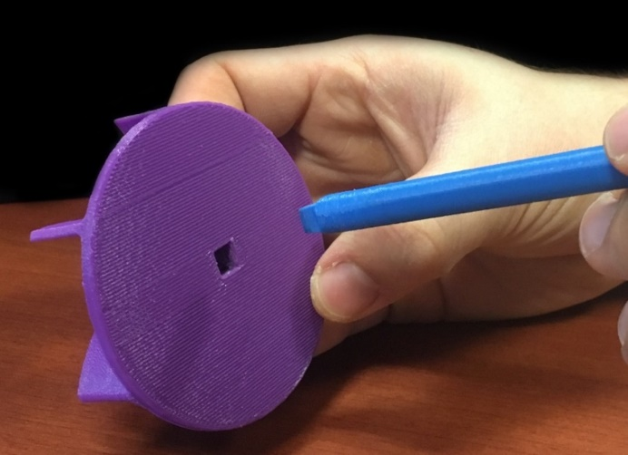  
**Figure B-1.** Connection of purple impeller and blue shaft [9].

1. *Place the second step of the instructions in italics.* Because this appendix is set of instructions, please feel free to use the pronoun *you.* Note, though, that while the pronoun *you* is appropriate for instructional texts, it is not appropriate in technical writing for texts that document a project or design. For a second illustration, see Figure B-2.
2. *Place the third step of the instructions in italics.* In general, the style for instructions differs significantly from the styles of proposals and reports, because the emphasis for the reader of a set of instructions is on the *how,* often without regard for the *why*. For that reason, the style of instructions includes vertical lists, use of the pronoun *you,* and occasional sentences written as commands. Also, be generous with illustrations, perhaps including an illustration with each step. For a third illustration, see Figure B-3.



**Figure B-2.** Pump shaft and volute [9]: feeding of pump shaft through the volute piece (left); assembly with second volute piece (right).

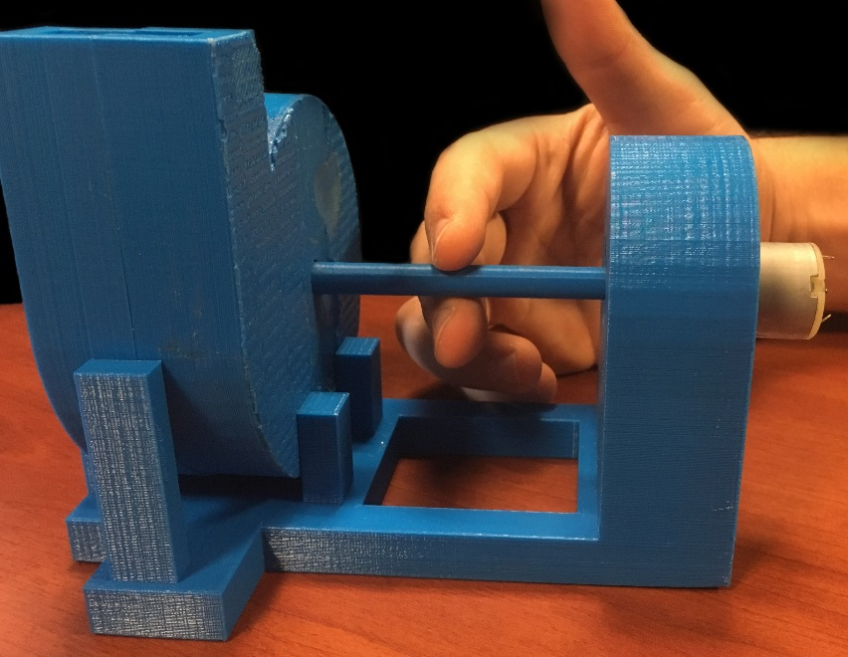

**Figure B-3.** Fully assembled system, which you can now connect to electrical power to turn the shaft [9]. Note that you can also use your hand to rotate the shaft, as is shown here.

After your list of steps, include a paragraph that provides closure to the set of instructions. Each appendix is to begin on a separate page. Titles of appendices are 14 points, flush left, and boldfaced. Use initial capitals. To preserve hierarchy, allot more vertical space before the appendix title than after it, as is incorporated here. Finally, be sure that you have introduced this appendix somewhere in the text of the report.

### Appendix C: Automatic Insertion of References

To assist you with listing and citing references in your reports, Microsoft Word includes a references tool. This tool allows for easy insertion of reference listings within the text as well as generating reference citations at the end of the report. This tool also reorders the reference listings and citations, even if you add or delete reference listings. As commonly done in engineering reports, this report’s format recommends an IEEE format, which calls for numbered listings in brackets to be placed within the text.

To insert a reference listing, click the “References” tab from the top ribbon. In the “Insert Citation” menu, select “Add New Source.” Both of these buttons are shown in Figure C-1. Upon clicking “Add New Source,” a window appears, prompting information about the source. Once you have inserted the information, a bracketed reference listing will appear with the number of the reference attributed to the source. This reference listing number corresponds to a reference citation number in the References section at the end of the report.

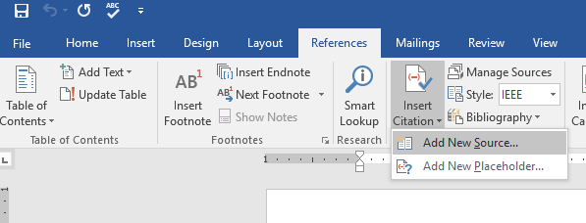

**Figure C-1**: The sequence of clicks to add a new source to a technical report. Move from “References” to “Insert Citation” to “Add New Source.”

Once you have completed the main text and appendices, insert a page break and add the References section. By clicking the “Bibliography” option, the references are automatically generated and formatted in the IEEE format. Figure C-2 shows the sequence of clicks to insert a References page. Note that because parentheses are used for so many purposes in engineering documents, such as for units or abbreviations, most engineering formats call for a references style that relies on bracketed reference listings similar to the IEEE format.

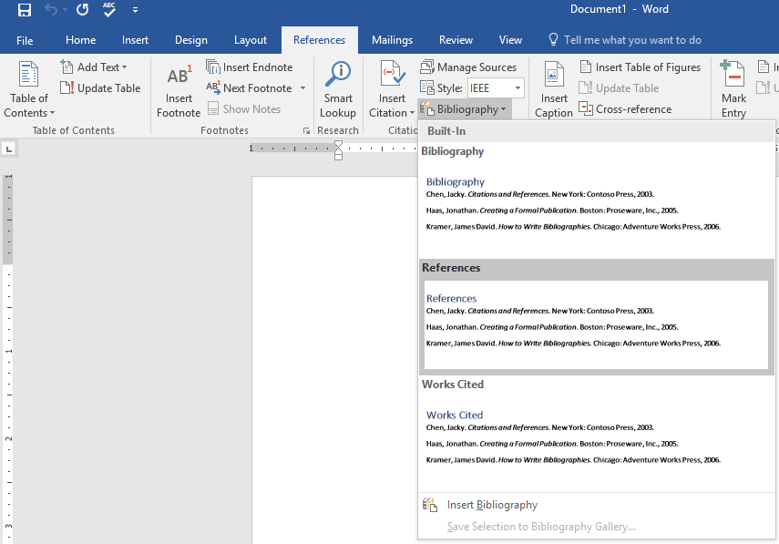

**Figure C-2:** The sequence of clicks to add a references section to a technical report.

If changes are made to the in-text citations in the text, be sure to “update” the references prior to completion of the report. As shown in Figure C-3, an update is performed by clicking the Reference Title and selecting update. Similar to appendices, the References section begins on a new page,

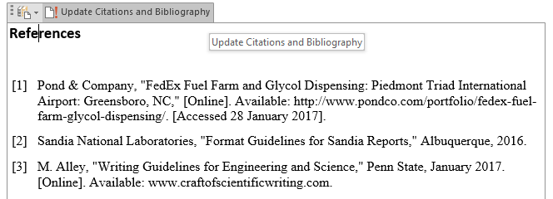

**Figure C-3:** The clicks for updating the References section of a technical report.

### References

1. Michael Alley, *The Craft of Scientific Writing,* 4th ed. (New York: Springer-Verlag, 2018).
2. K. L. Kirsch and K. A. Thole, “Experimental Investigation of Numerically Optimized Wavy Microchannels Created Through Additive Manufacturing,” *Journal of Turbomachinery,* vol. 140, no. 2 (2017), p. 021002.
3. J. Frank, “The Industrial Internet of Things: Predictive Maintenance in Advanced Manufacturing,” presentation (University Park, PA: ME 340, Penn State, 24 October 2016).

4. B. D. Payne, *“Simplifying Virtual Machine Introspection Using LibVMI*, Sandia report (Albuquerque, New Mexico: Sandia National Laboratories, 2012).

5. W. A. Kavasnak, F. O. Soechting, K. A. Thole, and G. A. Zess, “Apparatus and Method for Inhibiting Radial Transfer of Core Gas Flow Within a Core Gas Flow Path of a Gas Turbine Engine,” U.S. Patent 6,419,446 (August 1999).

6. Michael Houser, Engineer at Boeing Corporation, phone interview (2 July 2018).

7. “Writing Guidelines for Engineering and Science, ed. by Michael Alley, [www.craftofscientificwriting.com](http://www.craftofscientificwriting.com) (University Park, PA: Penn State, 1996).

8. Thomas Gryta, “In Delta Deal, United Technologies Gets a Boost for Troubled Engine Program,” *The Wall Street Journal* (15 December 2017), p. B-1.