Title of Formal Document
in Initial Capital Letters

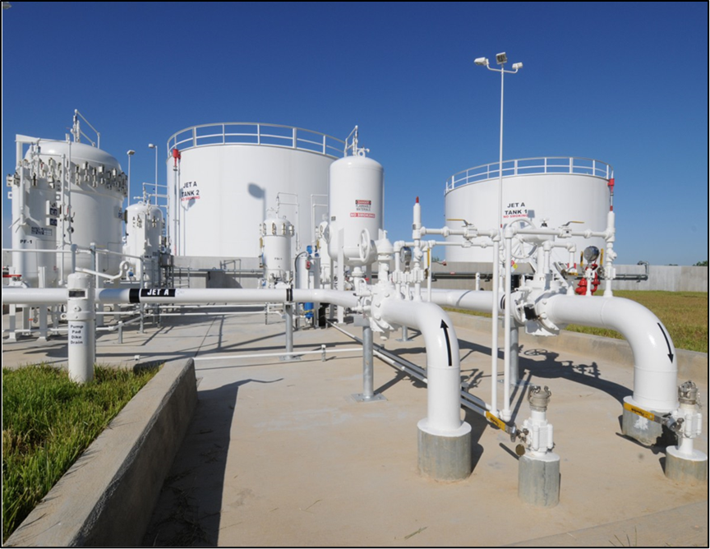
Pond & Company [1]

Name of Author 1

Name of Author 2

Name of Author 3

Name of Author 4
Department
Institution
Date

Title of Formal Document
in Initial Capital Letters

Name of Author 1

Name of Author 2

Name of Author 3

Name of Author 4
Department
Institution
Date

Summary
This template, which was created by Professor Michael Alley from Pennsylvania State University, presents a professional format for a longer document such as a proposal or report. The word format refers to the typography and layout of a document. Because no universal format exists for engineering reports, a publication or institution often specifies a format to serve the specific audience, purpose, and occasion of its documents. As an engineering or science student, you might use this format template for a course or an internship in which the professor or supervisor did not already specify a format. The format of this template arises from the professional format for formal reports at a large engineering research laboratory: Sandia National Laboratories [2]. Professional artists put much thought into the design of this format. For discussion of format design, please see Appendix D of The Craft of Scientific Writing [3] and the report format page of the website Writing Guidelines for Engineering and Science [4].
On this title page of the document, you have the opportunity to present a two- to three-paragraph summary of the most important details of the document. To be effective, this summary should stand alone. For that reason, you will want to orient the audience at the beginning and include needed background information. However, every detail that occurs in this summary should appear in at least that much detail in the main text of the proposal. For more information about summaries, please see pages 139-143 in The Craft of Scientific Writing [3].
The format of this document requires that the summary fits within this single title page. Also required are that you indent all paragraphs in this document and use a serif typeface such as Times New Roman (12 points) for the text portions. However, for the title, the headings, and subheadings, a bold sans serif typeface such as Calibri is fine to use. The line spacing for this paragraph is to be single-spaced at 1.15 spacing. Also, as in common in books and formal reports, please do not skip lines between paragraphs. For the title and section headings, you are to use initial capitals as shown in the title line above.

Contents

Summary ii

First Section of Main Text 1

Second Section of Main Text 2
First Subsection 3
Second Subsection 3
Third Subsection 4

Third Section of Main Text 5

Appendix A: Generic Appendix 7

Appendix B: Automatic Incorporation of References 8

References 11

First Section of Main Text
This section is the first main section of the main text in the report. The pages up to this point constitute the front matter—you can tell if you are in the front matter because the page numbers will be lowercase roman numerals. In contrast, the page numbers in the main text and back matter will be Arabic numerals.
In most technical documents, the heading of this section will be “Introduction.” If the document is a proposal, a common first heading would be Statement of Problem.” In the format of this formal document, note that all major headings are 14-point font, flush left, and boldfaced. Use initial capitals for the heading title. To preserve hierarchy, insert more vertical space before the heading than after it, as shown in this template.
In this document, please indent all paragraphs and do not insert a line skip between paragraphs within the same section. In addition, use a serif typeface such as Times New Roman (12 points) for the text portions of the document. While a sans serif typeface such as Calibri is appropriate for headings and the call-outs of illustrations, sans serif type is not recommended for large blocks of text. As occurred in the text for the summary, the line spacing for paragraphs in the main text is to be single-spaced at 1.15 spacing, which is common in professional documents. For the title and section heading, use initial capitals as shown in the section heading above. An explanation of initial capitals occurs on the report format page of the website Writing Guidelines in Engineering and Science [4].
In this section, you are encouraged to include illustrations. Possibilities include a photograph that depicts the need or a table showing the wind conditions in the region. Please note that each illustration should be introduced by its formal name (Figure 1, Table 1, and so forth) in the report before the illustration appear. As an example, please consider Figure 1, which shows a photograph from a previous year’s design proposal—in this case, a pump station for transporting airplane fuel to an airport. In introducing an illustration, do not use pointers such as “below” or “on the next page.” Such tags are not only unnecessary, but also unwanted. Moreover, note that putting labels in figures can be an effective way to emphasize the most important details. Finally, make sure that the figure caption describes what the reader should see. As is common in reports, the caption for Figure 1 consists of a defining phrase, which is often followed by a sentence that explains unusual details.
Because you are writing as an engineer, the style of the writing is significantly different from the writing style of other disciplines such as creative writing. For example, in engineering and scientific writing, avoiding ambiguity is critical. For that reason, many scientific editors recommend not using the word this as a standalone pronoun, but using this word to point to a noun or noun phrase: “this device” or “this vibration at resonance.” In addition, unlike poets, when engineers and scientists want the meaning of “because,” they use the word because, rather than the word as. The reason is that the word because has only one meaning, while the word as carries other meanings such as “while.” As a third example of this difference between scientific writing and creative writing, engineers and scientists place a comma after an introductory clause, phrase, or transition word (the word however, for example) so that the reader can see where the introductory part of the sentence ends and the main part of the sentence begins. As a fourth and final example, engineers and scientists do not use contractions, such as isn’t, because contractions are simply considered too informal for formal documents in engineering and science. More explanation about these differences can be found in The Craft of Scientific Writing [2].

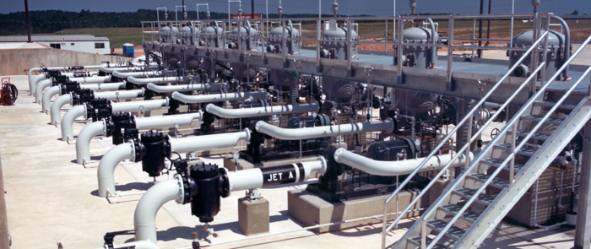
Figure 1. Pump station that uses vertical pumps to transport jet fuel from underground storage tanks to the airport [5]. Note that the text size of the caption is smaller (10 points) than the size in the main text. Also, the line spacing is 1.0 spacing. Such a difference serves to separate the caption text from the body text. Finally, note the vertical space given before the image and after the caption.

Second Section of Main Text
This section is the second main section of the report’s main text. In this format, the sections of the main text follow one another without a forced page break. In longer documents that are book length, such as a dissertation, you should consider referring to the main sections as chapters and beginning each chapter on a new page.
This particular section has three subsections. Note that you should not have a subheading immediately follow a section heading. The reason is that because subsections break the section into parts, you want to clarify for the reader how many parts you have and what those parts are. In addition, the text between the heading and the first subheading is an opportunity to provide overall background for the section.
To make a smooth transition to the subsections, you should map those subsections in the paragraphs between the section heading and the first subsection. Note that different sentence openers exist for these sentences other than the standard “The next subsection presents….” For instance, you could begin with “Given next is the function structure and system decomposition of a small-scale wind turbine.” Because the subsections exist on the page, the preferred tense for these sentences is present tense (“The next subsection presents….”), rather than future tense.
First Subsection
This subsection is the first subsection of this section. Because a subsection has a lower level of importance than a section, the subheading is distinctly smaller than a heading. In our format, the subheading should be 12 points and boldfaced. As with a heading, more vertical space precedes a subheading than follows it. As with a heading, you should use initial capitals for a subheading. Finally, the first sentence should orient the audience to contents of the subsection.
As with sections, you are free to incorporate illustrations into a subsection. For example, given in Table 1 is a matrix giving the needs, metrics, and specifications of a design for a cardboard chair. As stated earlier, each illustration should be introduced by name before it appears in the text. Note that you should not interrupt a paragraph to insert an illustration.

Table 1. Customer needs and accompanying metrics and specifications for cardboard chair.
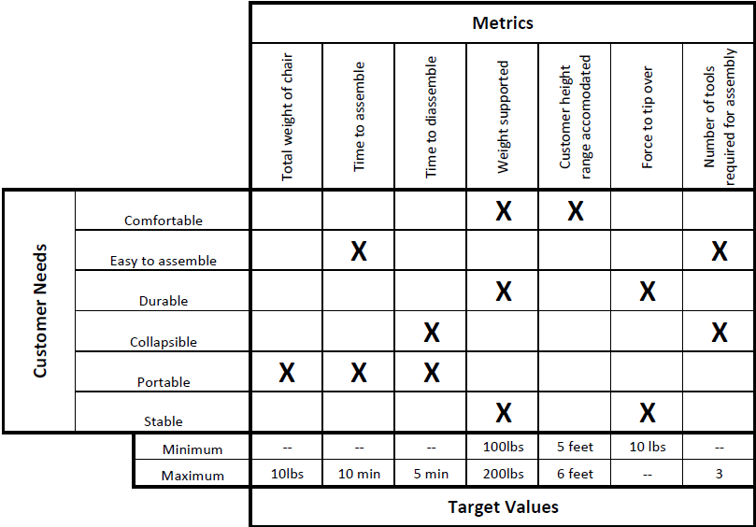

Second Subsection
This subsection is the second subsection of the section. As stated before, subheadings should be 12 points and boldfaced. Also, the amount of vertical space before and after this subheading should be the same as occurred for the previous subheading. For the subheading, you should use initial capitals.
In writing documents in engineering and science, you should support your claims with statistics from reference sources. For reference listings in the text, this format follows the IEEE format, which calls for placing reference listings as numbers within brackets in the text. Because engineers and scientists use parentheses in so many ways, most formats in engineering and science use brackets rather than parentheses for reference listings. Note that every reference listing in the text corresponds to a reference citation at the end. Likewise, every citation at the end has at least one reference listing in the document. In the references section at the end of the document, you will find sample citations for a book [2], a journal article [6], a company brochure [7], a presentation [8], a company report [9], a patent [10], an interview [11], a newspaper article [12], and a website [2]. Refer to Appendix B to learn an automatic way to number and insert references.
Third Subsection
This subsection is a third subsection in this section. This subsection presents an example of how to incorporate sub-subsections. As with subsections, you should not use sub-subsections unless the length warrants doing so. In other words, if the subsection is only a few paragraphs, you should simply use paragraphs to show the subsection’s organization.
Not listed in the Table of Contents, the sub-subsections should have a format that reveals less hierarchy than the subsection. Given below are two sub-subsections: one for incorporating tables and one for incorporating equations. In your proposal, your sub-subsections might be as follows: Blade Design, Transmission Design, Stand Design, and Overall Design. In that last sub-subsection, you would include the required efficiency calculation.

Incorporating Tables. Tables are rows and columns arrangement of words and numbers. As shown in Table 2, tables are formatted in a fashion that is different from figures. Unlike figure captions, which follow the figure and may include an additional sentence or two, a table heading is a single phrase. In addition, the heading for the table precedes the table and is 12 points. If unusual details exist in the table, those are explained in footnotes beneath the table. Finally, please make sure that all figures and tables are numbered and labelled in the text and that they are referenced during your writing. This convention also means that you should explain each figure or table in the text to make sure that the reader knows what to look for when reviewing that figure or table.

Incorporating Equations. To incorporate an equation, such as for an efficiency calculation, center and set apart equations from the text with white space. Using Arabic numerals, number those equations that are referred to in the text. For example, in a wind turbine, the torque supplied by the rotor, T_{rotor_S}, is defined in equation 1:
$T{}_{rotor_S}= \frac{1}{2}C_{m}ρARU^{2}$ (1)
where C_{m} is the rotor-torque coefficient, ρ is the air density, A is the rotor’s cross-sectional area, R is the radius of the rotor, and U is the air velocity. When referring to equations, call them by their names: equation 1, equation 2, and so on. Also, when incorporating an equation, treat the equation as part of a sentence in the paragraph. For instance, in the wind turbine project, important calculations concern the power output to the application, P_{app}. One such calculation is for the torque needed for P_{app}. This torque, T_{rotor_N}, is defined in equation 2:
$T_{rotor_N}=\frac{P_{app}}{{ω_{rotor}}_{gen}}$ (2)
where ω_{rotor} is the angular velocity of the rotor, and η_{gen} is the efficiency of the generator. Notice that you define the dependent variable before the equation appears and you define any new independent variables beneath the equation. Once you have defined those variables once in the proposal, you need not define them again. Finally, do not let Microsoft indent or capitalize the word where in the part of the sentence beneath the equation.
Table 2. Example of concept scoring matrix that often occurs in design documents [13].
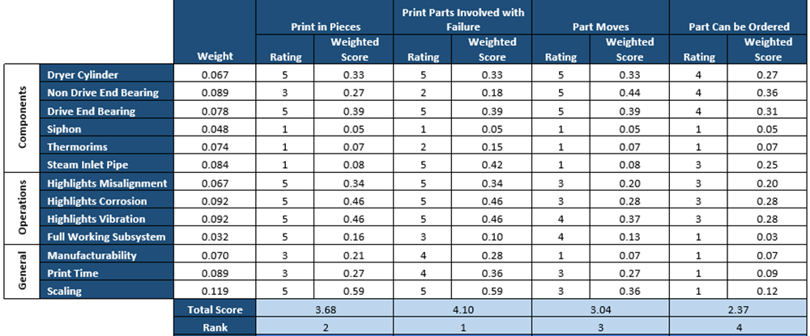

Third Section of Main Text
This section is the third section of the main text. In this template, this third section is the final section. If your main text has additional sections in the main text, those sections would be formatted in a similar fashion as the three provided here.
Presented in this section is an example system decomposition shown in Figure 2. Such a decomposition is a common illustration in a design report. In addition to the main text, your document will likely have back matter. The back matter would include appendices, a glossary perhaps, and the list of reference citations. If you include an appendix such as Appendix A, you should introduce that appendix by its formal name somewhere in the main text. Unlike the sections of the main text, each appendix and the reference page begin on a new page.

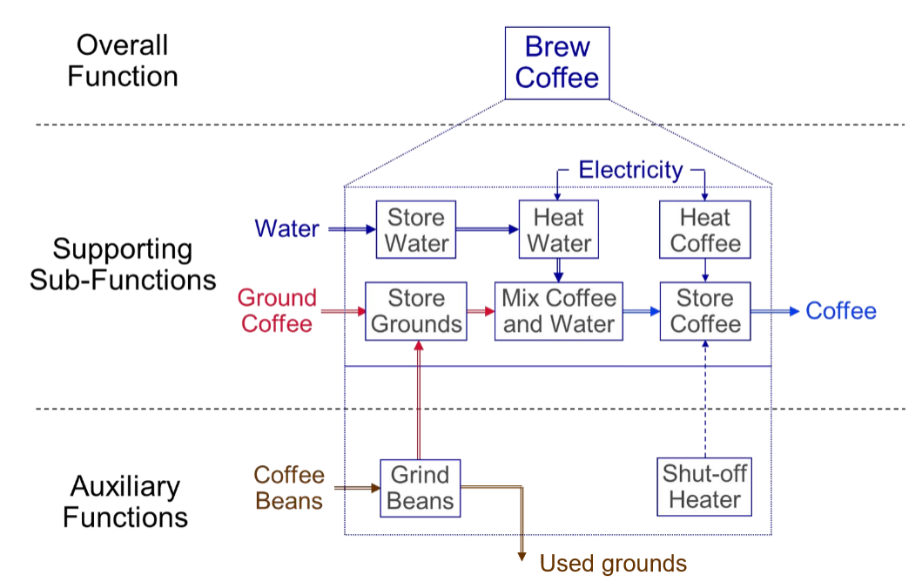
Figure 2. System decomposition of a coffee-maker [14]. By looking at the energy, material, and signal flows going into and out of a sub-function, we learn what is needed to design this sub-function and with what resources we have to work with. For instance, for the sub-function “heat water,” inputs would be water (material), electricity (energy), and on-off switch (signal). The outputs would be hot water (material), heat (energy), and on-off switch (signal). In your report, you will want to include a specific decomposition of your team’s wind turbine.

Appendix A: Generic Appendix
This appendix presents a generic appendix. For more information about appendices, please see pages 148-151 in The Craft of Scientific Writing [3]. Be sure to support all choices with information derived from external (preferred) or internal searches. As an example, see Table A-1. As given in this template, each appendix is to begin on a separate page. Titles of appendices are 14 points, flush left, and boldfaced. Use initial capitals. Illustrations in the first appendix are labeled Figure A-1, Figure A-2, Table A-1, Table A-2, and so forth. As mentioned, each appendix should be introduced somewhere in the text portion of the report.
Table A-1. Example of an Analytical Hierarchy Process (AHP) matrix for a design proposal [16].
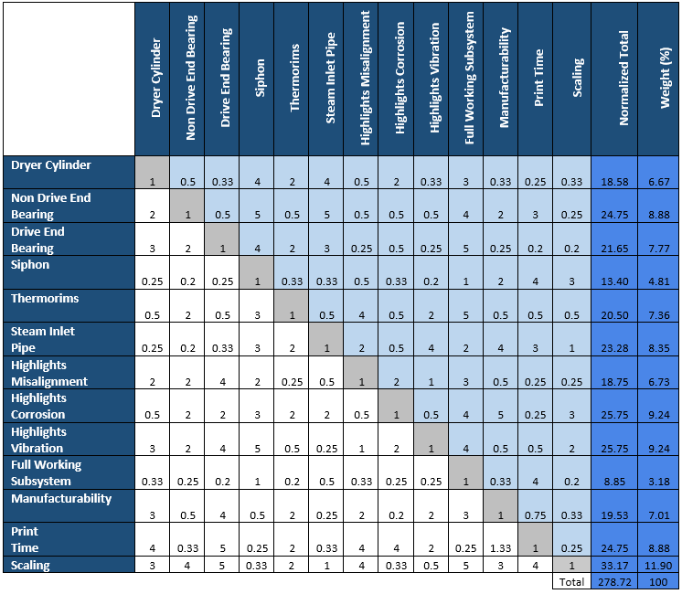

Appendix B: Automatic Incorporation of References
To assist you with listing and citing references in your documents, Microsoft Word includes references tool. This tool allows for automatic numbering of reference listings within the text as well as automatic generation of reference citations at the end of the report. This tool also reorders the reference listings and citations, even if you add or delete reference listings. As commonly done in engineering reports, this report’s format recommends an IEEE format, which calls for numbered listings in brackets to be placed within the text.
To insert a reference listing, click the “References” tab from the top ribbon. In the “Insert Citation” menu, select “Add New Source.” Both of these buttons are shown in Figure B-1. Upon clicking “Add New Source,” a window appears, prompting information about the source. Once you have inserted the information, a bracketed reference listing will appear with the number of the reference attributed to the source. This reference listing number corresponds to a reference citation number in the References section at the end of the report.

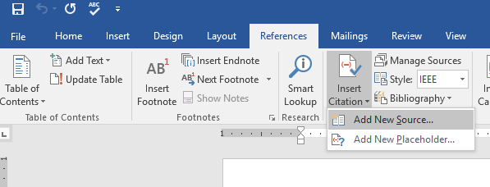
Figure B-1: The sequence of clicks to add a new source to a technical report. Move from “References” to “Insert Citation” to “Add New Source.”
Once you have completed the main text and appendices, insert a page break and add the References section. By clicking the “Bibliography” option, the references are automatically generated and formatted in the IEEE format. Figure B-2 shows the sequence of clicks to insert a References page. Note that because parentheses are used for so many purposes in engineering documents, such as for units or abbreviations, most engineering formats call for a references style that relies on bracketed reference listings similar to the IEEE format.
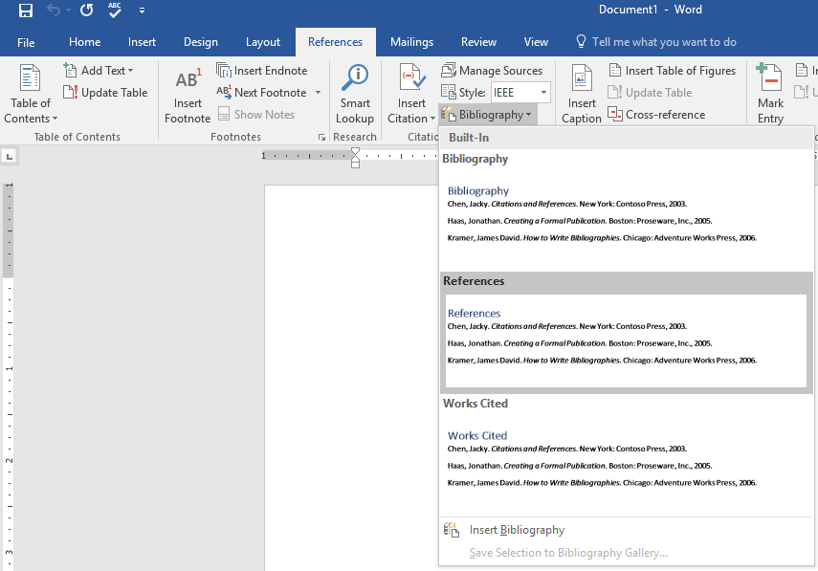
Figure B-2: The sequence of clicks to add a references section to a technical report.
If changes are made to the in-text citations in the text, be sure to “update” the references prior to completion of the report. As shown in Figure B-3, an update is performed by clicking the Reference Title and selecting update.

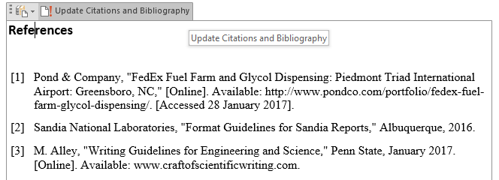
Figure B-3: The clicks for updating the References section of a technical report.
Because this appendix was included solely to help you with the formatting of the reference citations, please be sure to delete this appendix before submission of your team’s proposal. Also, please remember that each appendix as well as the References section are to begin on a new page.

References
- Pond & Company, “FedEx Fuel Farm and Glycol Dispensing: Piedmont Triad International Airport: Greensboro, NC,” http://www.pondco.com/portfolio/fedex-fuel-farm-glycol-dispensing/ (accessed 28 January 2017).
- Sandia National Laboratories, “Format Guidelines for Sandia Reports,” SAND 90-9001 (Livermore, CA: Sandia National Laboratories, 1990).
- Michael Alley, The Craft of Scientific Writing, 4th ed. (New York: Springer-Verlag, 2018).
- Writing Guidelines for Engineering and Science, ed. by Michael Alley, http://www.craftofscientificwriting.com (University Park: Penn State, 1996).
- Caddell Construction Company, “Bulk Fuel Storage Facility: Raleigh-Durham Airport, NC,” http://www.caddell.com/aviation/airport-infrastructure/bulk-fuel-storage-facility.aspx (accessed 28 January 2017).
- K. L. Kirsch and K. A. Thole, “Experimental Investigation of Numerically Optimized Wavy Microchannels Created Through Additive Manufacturing,” Journal of Turbomachinery, vol. 140, no. 2 (2017), p. 021002.
- D. Cheng, “Chemtronix XT Manometer,” brochure (Asheville, N.C.: Chemtronix Corporation, 1974).
- J. Frank, “The Industrial Internet of Things: Predictive Maintenance in Advanced Manufacturing,” presentation (University Park, PA: ME 340, Penn State, 2 October 2016).
- B. D. Payne, “Simplifying Virtual Machine Introspection Using LibVMI, Sandia report (Albuquerque, New Mexico: Sandia National Laboratories, 2012).
- K. A. Thole, “Apparatus and Method for Inhibiting Radial Transfer of Core Gas Flow within a Core Gas Flow Path of a Gas Turbine Engine,” US Patent 6,419,446 (August 1999).
- Atul Kohli, Senior Technical Fellow at Pratt & Whitney, phone interview (14 June 2018).
- Loren Thompson, “Pratt & Whitney Surges U.S. Hiring as Bet on Geared Turbofan Pays Off,” Forbes (17 July 2017).
- A. Kumar, N. Nace, J. Benton and F. Santilli, “Proposal to Print a 3D-Model of a Paper Dryer Roller to Represent Bearing Failure” (University Park, PA: ME 340, Penn State, 2016).
- ME 340 Teaching Team, “Lab 6: Functional Decomposition and Analytic Hierarchy Process,” presentation (University Park: Mechanical Engineering Department, Penn State, 2016).

